The Mountain PreHEAT is a celebration of woodfired ceramics centered around the Asheville area of Western North Carolina. The organizers of the PreHEAT have assembled the region’s top woodfirers and a host of national and international guests for seven days of complete immersion into the exciting world of woodfiring. Join us for an action packed week of programming from May 21st through the 27th highlighted by the firing of 5 different wood kilns. Every attendee is guaranteed a total of 5 cubic feet of their own bisque ware spread throughout the various kilns. In addition to actively taking part in loading and firing the kilns, participants can also engage in a full array of exhibition receptions, demonstrations, area kiln tours, feasts, parties, tango lessons, music, general merriment, the Clay Olympics, and a super special fashion show. This event promises to offer something special for everyone involved.
All kilns will be unloaded after the main WoodfireNC conference on Monday June 1st starting at 10AM
Starting May 21st, the Mountain PreHEAT artists, invited guests, and attendees will be loading and firing five kilns, each one a distinct style, at two main kiln sites, and participants will get a chance to experience an array of different firing styles and see their work fired with a variety of unique effects. Participants are guaranteed to get 5 CU FT of work in the firings. That equals 3 and a half shelves (12” x 24”) of 9” pots OR a 22” cube. (All work for the firing should be bisqued and preferably decorated/glazed upon arrival. Limited glaze and slips will be provided at each of the kiln sites. Please direct all shipped work to 119A Roberts St Asheville NC 28801)
When a participant is not actively involved in loading or firing one of the five kilns, there will be plenty of other opportunities to explore the rich woodfiring community of this area. Two guided tours of area woodfired potteries will allow participants a direct insight into the studio practices and kiln philosophies of our presenters.
The Mountain PreHEAT offers three full days of demonstrations by some of the field’s top makers, numerous exhibition openings, and a special evening banjo concert by our very own Akira Satake (and friends). Attendees will also get a complimentary taco party, beer provided by Sierra Nevada, a tango lesson from Eric Knoche, a commemorative hat, and much more. The week will culminate at the Copus Compound with a Clay Olympics event, coordinated by Neil Hoffman, and a woodfired pizza celebration as all three of Josh’s kilns are finished at the same time.
All participants will receive a registration email detailing information about shipping work, what to expect when you arrive, and how best to prepare for the pre-conference after you register. No transportation is provided for traveling to the various pre-conference event sites.
Complimentary on site primitive camping is included at the Copus Compound and all participants are encouraged to create a festive camp vibe.

Kilns

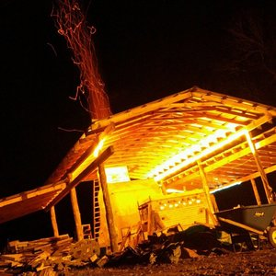

Joey Sheehan
He calls his kiln the Golden Antelope. It is a two chamber wood burning kiln and is designed after the extended throat bourry box kilns described in Steve Harrison's book Laid Back Wood Firing. He describes the kiln as a double barrel snub nose train chamber in the front with a catenary in the back. The front chamber is nitty and gritty with a lot of ash and wood in direct contact with the pots, while the back chamber is essentially a reduction glaze chamber with some flashing.
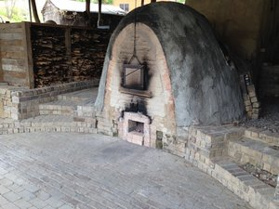

Josh Copus Compound
Temple (climbing or noborigama)
The Temple is a 3 chamber climbing kiln (noborigama) with 330 cubic ft. of total stacking space evenly divided amongst the 3 chambers. Designed in collaboration between Josh Copus and Will Ruggles, the Temple was built in 2007 and has been fired 38 times to date.
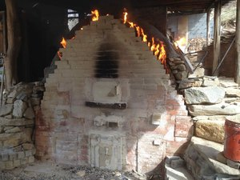
Josh Copus Compound
Land Shark (tube or anagama):
The Land Shark is a 19 foot long tube kiln that is essentially half land and half shark… hence the name. It has 240 cubic feet of stacking space. The whole ware platform is a flat floor from the firebox to the chimney, so it is ideal for accommodating large work. There are 4 side stoke channels over the length of the kiln that create lots of opportunities for ember contact throughout the whole kiln. We generally actively fire for 72-80 hours so there is a fairly heavy amount of natural ash deposits, vapor glazing and other woodfire “effects”. Good for unglazed ceramics although it does have a lot of different zones, some of which are quiet.
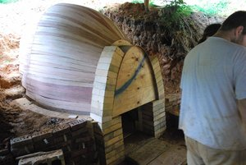
Josh Copus Compound
Burrow (egg shape or anagama):
The Burrow is a 13-foot long egg shape kiln that has 120 cubic feet of stacking space and is totally buried in a hillside. It was inspired by historic kilns that were dug out of clay banks in hillsides. It is an experimental kiln, and this will be its first firing. We plan to do a fairly fast active firing and a really long slow controlled cooling. Having never fired it, I don’t really know what to expect, although we hope to get minimal melted ash deposits and a really rich deep dark clay color.

